FPGA Intermediate Workshop
  - Authors:
Owen Grimm <ozgrimm@uwaterloo.ca>
Syed Fuzail Farhan <msffarhan@uwaterloo.ca>

Introduction
In this workshop, you will build a functional version of Pong. You will combine several pre-built elements with your own VHDL to display patterns over HDMI, keep track of game objects and state, and render the game. By the end of this workshop, you should:
- Understand the advantages of licensed IP cores and how to use them in Quartus Prime
- Learn how to write reusable logic and integrate multiple components together to create a cohesive product
- Know how and when to use conditional assignments
- Be able to write idiomatic state machines
If you do not have Quartus Prime Lite installed already, please follow the guide available here and install it as soon as possible.

Background

Logic Reuse in VHDL
In VHDL, components (entity/architecture pairs) may be reused in different portions of your logic. These components may be instantiated, which creates a copy of them in the logic gates of your FPGA. These copies may have their inputs and outputs connected to other signals in your program. This allows designers to reuse components within and across designs, organize their logic hierarchically, and create vastly more complicated designs via abstraction.

Intellectual Property Cores
Intellectual property (IP) cores are reusable logic components for use in FPGA/IC/ASIC design that are the intellectual property of another party. Designers can obtain a license to use IP cores for use in their designs, offering designers the advantage of a pre-built, pre-tested logic component. They can drastically reduce the development time of hardware designs, and as such are widely used in industry. Intel Quartus Prime Light comes packaged with a small library of IP cores with varying licenses. The included IP cores include cores for DSP, interface protocols, among others. It also includes the Nios family of soft-core processors; these are customizable processors implemented in HDL for the Altera family of FPGAs.

ADV7513 HDMI encoder
The ADV7513 HDMI encoder is a chip on board the FPGA. It allows the FPGA to interface with an HDMI-enabled display. The chip is configured over I2C (a serial protocol) and the display data is sent over a parallel interface (consisting of 24 bits of RGB data, horizontal and vertical sync signals, a pixel clock, and a data enable signal), as shown in Figure 1. For more information on how the I2C parallel interface works, see Appendix A. For more information on the video signal transmitted to the ADV7513, see Appendix B.
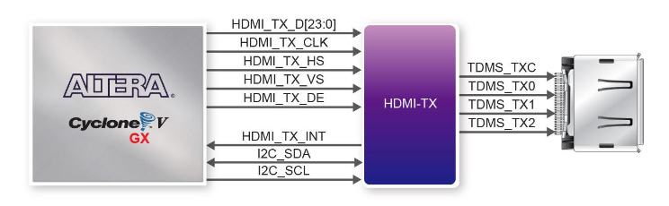
Figure 1 - ADV7513 HDMI encoder connections

Computer Graphics
Displays are (typically) made up of grids of square pixels. Each pixel can display a range of visible colors by combining varying levels of red, green, and blue light. To see how these elementary colors combine to form different colors, see this interactive tool.
For most display applications, a standard coordinate system is used to describe the position of a pixel. In this coordinate system, the x-axis increases from left to right, from 0 to width-1, where width is the width of the screen in pixels. Similarly, the y-axis increases from top to bottom, 0 to height-1. See Figure 2 for an illustration of this coordinate system.
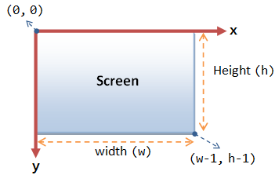
Figure 2 - Screen-space coordinate system

Numeric Types in VHDL
Today, we will use some new numeric types from the IEEE.NUMERIC_STD library. This library offers some new useful types: SIGNED, and UNSIGNED. It also implements arithmetic operators on these types, like addition, subtraction, multiplication, and division. The SIGNED and UNSIGNED types are similar to STD_LOGIC_VECTOR in how they are defined and used (i.e., they must be declared with a set size and are indexable). UNSIGNED is a type that represents positive (or zero integers), while SIGNED is a type for any integer (positive, negative or zero).
Additionally, VHDL has some built-in types for numbers: INTEGER, NATURAL, and POSITIVE. These have predefined sizes (typically 32 bits) and cannot be indexed.
A table comparing these types is below:
Type | Size | Range | Source
SIGNED | User-Chosen | Variable, +/- | IEEE.NUMERIC_STD
UNSIGNED | User-Chosen | Variable, >=0 | IEEE.NUMERIC_STD
INTEGER | Fixed Implementation | -2³¹ to 2³¹-1 | Built-in
NATURAL | Fixed Implementation | 0 to 2³¹-1 | Built-in
POSITIVE | Fixed Implementation | 1 to 2³¹ | Built-in

Do not worry about memorizing this information, but if you’re confused about the usage of a specific numeric type, feel free to refer back to it.

Part 1 – Project Setup
To begin the workshop, download and unzip the skeleton project file, available here. The skeleton project contains some files to save time during the workshop.
More information about what each file does and how they work will be shared as they are used. For those interested in learning more, feel free to examine the VHDL files and the appendices in this document.
After opening the project, the file explorer should look like this:
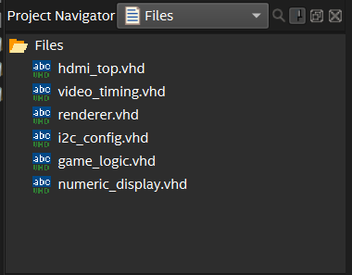

Part 2 – Setting up a Phase-Locked Loop
In this part, we will learn how to set up an IP core from the Altera IP library.
Several logic components we use in this workshop require a 74.25MHz clock. However, the development board we are using only includes a 50MHz internal clock. To generate a 74.25MHz signal from the provided 50MHz signal, we will use a device called a phase-locked loop (PLL). At its core, a PLL generates a clock that is in-phase with another clock. Using clock dividers to pre-scale the input and feedback, a PLL may generate new clock frequencies at their output that do not drift over time with respect to their input clocks. To learn more about PLLs, see Appendix C.
Instead of writing this component from scratch, we can use a pre-built, pre-tested component from the Altera IP library. To do so, we use the IP library in Quartus:
- Open the IP Catalogue using the Open IP Catalogue button (see below) or by pressing Alt+7.
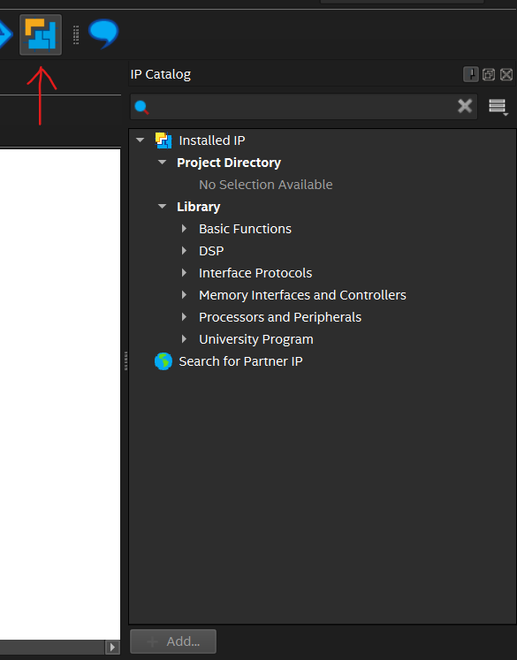
- Search the IP Catalogue for “PLL Intel FPGA IP” and select it from the list.
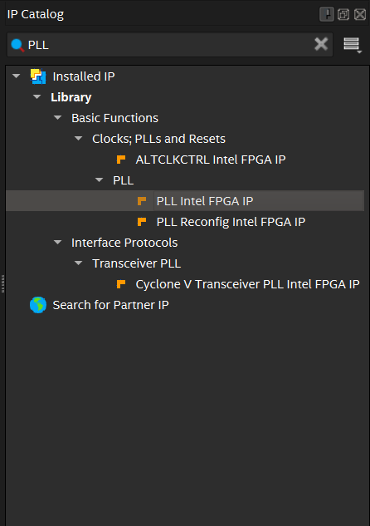
- In the popup, choose a name for the generated IP variation (here, we chose “pll_74mhz”) and select the VHDL radio button. Then, press OK.
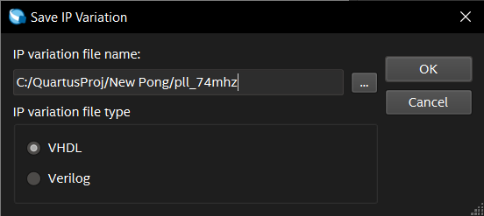

- Wait for the MegaWizard to load. This may take a couple seconds.
- In the MegaWizard, change the following parameters:
  - Reference Clock Frequency: 50.0MHz
  - Desired Frequency: 74.25MHz
  - Actual Frequency: 74.242424MHz (should be auto selected after inputting desired frequency)
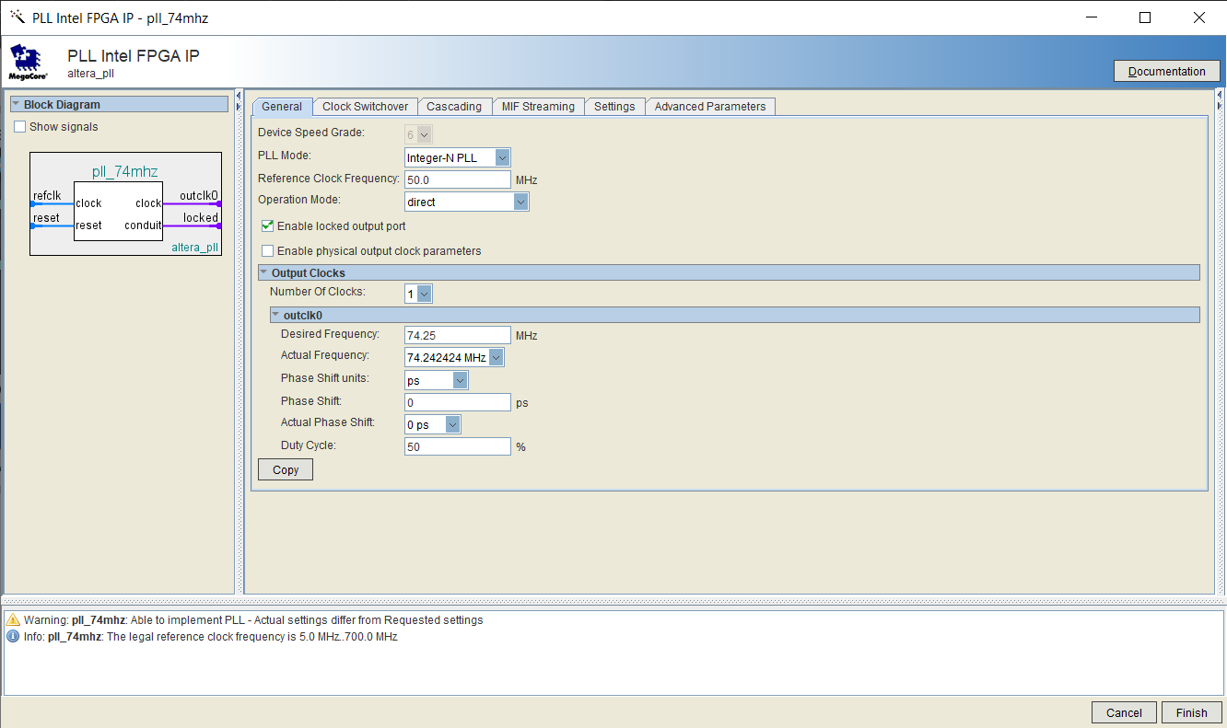
- Click finish. Await the “Generation Successful” message in the Generation window that appears.
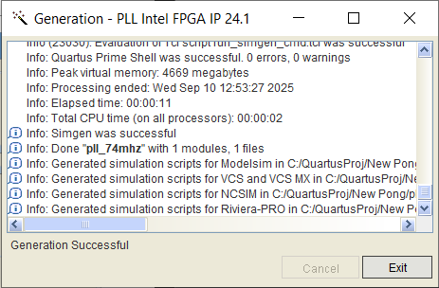
- If you receive a popup asking to add the generated IP variation file to the project, check the box and press Yes.
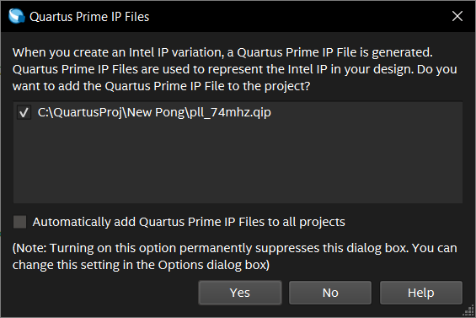
- The PLL IP variation is now available to use as a component in the project. To see the generated design files, find the project navigator (on the left of the screen). In the dropdown menu at the top of the project navigator, select “IP Components”. Right click on the PLL component you just generated and select Locate Node > Locate in Design File to open the generated design file.
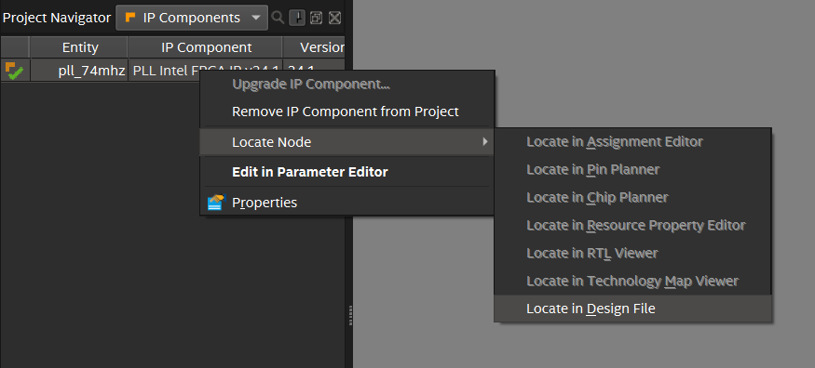
To use the generated PLL component in our logic, we will need to write a component definition in hdmi_top.vhd, then instantiate the PLL. Component definitions are a VHDL syntax element that informs Quartus about the presence and structure of a logic component in our project.
In the declaration portion of our hdmi_top architecture (i.e., before the begin keyword), we’ll add the component definition:

component pll_74mhz is
port (
refclk : in STD_LOGIC;
rst : in STD_LOGIC;
outclk_0 : out STD_LOGIC;
locked : out STD_LOGIC
);
end component;

This informs Quartus that, somewhere in our project, there’s a component named pll_74mhz with two input ports and two output ports of the STD_LOGIC type.
Next, to incorporate the component into our design, we must instantiate it. Underneath the begin keyword in our hdmi_top architecture, we’ll add the following instantiation:
pll_clock: pll_74mhz
port map (
refclk => clock_50_b5b,
rst => reset,
outclk_0 => clk_pixel,
locked => pll_locked
);

This tells Quartus to generate logic gates to implement the PLL, and how to connect its inputs and outputs. In this case, we’re connecting an internal 50MHz clock to the refclk port, our reset signal to the rst port, our pixel clock to the outclk_0 port, and our PLL locked signal to the locked port.
Now, using the same method used in the Introductory Workshop, set up a reset signal, a clk_pixel signal, and a pll_locked signal. Since reset is an input to our PLL clock, we must drive it ourselves. Write a statement to drive reset to the opposite value of cpu_reset_n, since the default behavior of the reset button is active-low.

Part 3 – Displaying Over HDMI
In this part, we will work towards displaying a test pattern on an HDMI display.
To do so, we’ll first set up the video_timing.vhd module. Opening the file, we can see the following entity declaration:
entity video_timing is
generic (
H_ACTIVE: NATURAL := 1280;
V_ACTIVE: NATURAL := 720
);
port (
clk: in STD_LOGIC;
reset: in STD_LOGIC;
hcount: out UNSIGNED(11 downto 0);
vcount: out UNSIGNED(11 downto 0);
hsync: out STD_LOGIC;
vsync: out STD_LOGIC;
de: out STD_LOGIC;
frame_start: out STD_LOGIC
);
end video_timing;

This entity declaration introduces a new VHDL construct, the generic. Generics allow you to parametrize your components. In this case, our video_timing component has two generics, H_ACTIVE and V_ACTIVE, with default value 1280 and 720, respectively.
To use this component in our project, we must instantiate it in our top-level design file:
- In the architecture declaration of hdmi_top.vhd, we’ll create the following signals to support our video timing generator (remember to put them before the begin keyword):
hcount | INTEGER | x-pos of current pixel
vcount | INTEGER | y-pos of current pixel
hsync | STD_LOGIC | horizonal sync pulse
vsync | STD_LOGIC | vertical sync pulse
de | STD_LOGIC | whether the current pixel is visible on the screen
frame_start | STD_LOGIC | pulse that goes high once per frame
- In the same architecture declaration, this time within the logic section (below the begin keyword), we need to instantiate the component. We will use a new syntax to instantiate this component, which looks like this:
instance_name: entity library.component_name
generic map (
GENERIC1 => constant1,
GENERIC2 => constant2
)
port map (
port_input => signal1,
port_output => signal2,
port_const_in => 0,
port_expr_in => not signal2
);

In our case, since our components are part of our project and not a library, we use the reserved VHDL library work, which refers to the current project. Additionally, we want to use the default generic values, so we can omit the generic map portion. So, to instantiate our video timing module, we will write something like this:
video_timing: entity work.video_timing
port map (
clk => clk_pixel,
reset => not pll_locked,
hcount => hcount,
vcount => vcount,
hsync => hsync,
vsync => vsync,
de => de,
frame_start => frame_start
);
Of note, we can only instantiate one component of a given type in an architecture using the above syntax. To instantiate more than one of the same component in an architecture, we must use a component definition, like we used for the 74MHz PLL.
To learn more about the video timing component, see Appendix B.
- Now that we’ve instantiated our HDMI component, we must connect its outputs with the ADV7513 HDMI encoder. To do this, assign the output signals hdmi_tx_de, hdmi_tx_hs, hdmi_tx_vs, and hdmi_tx_clk to de, hsync, vsync, and clk_pixel, respectively.
With the parallel HDMI transmit data set up, we need to configure the I2C module to power on and configure the ADV7513. To do this, follow the same steps as above to instantiate the i2c_config component. The clk input should be connected to our 74MHz PLL clock, the reset input to the expression (not pll_locked) or reset, scl to i2c_scl, and sda to i2c_sda.
Now, compile the project and resolve any errors. The board will not display anything over HDMI yet.

Part 4 – Test Patterns
With the HDMI system working, we will now write some logic to display a pattern over HDMI. We will use the provided renderer component to interface with the video timing signals and choose a color for each pixel on the display. It has three inputs and one output. The three inputs are:
- hcount, the horizontal/x position of the current pixel
- vcount, the vertical/y position of the current pixel
- de, whether we should be drawing to the screen
It has one output, rgb, which is the RGB color to draw on the pixel specified by hcount and vcount.
First, instantiate the renderer component in hdmi_top. Connect the rgb output to hdmi_tx_d to send color data over HDMI.
Note that rgb is an STD_LOGIC_VECTOR. It can be assigned as a whole:
rgb <= x"rrggbb";
Or, certain segments can be assigned individually:
rgb(3 downto 0) <= x"rr";
rgb(7 downto 4) <= x"gg";
rgb(11 downto 8) <= x"bb";
In the above examples, "rr", "gg", and "bb" are the red, blue, and green channels of the color for the current pixel, respectively.
For this part of the project, you will write logic to display a pattern in renderer.vhd. In the process in renderer’s architecture, write logic to choose the color of the current pixel based on hcount and vcount. Feel free to be creative and try something without knowing what the result will be. Warning: this step may produce flashing patterns that can trigger seizures for people with photosensitive epilepsy.
Some options for ways to generate the pattern include:
- Assigning red, green, and blue values based on bits in hcount and vcount
- Color every other pixel white, alternating colors every frame
- Draw a checkerboard with different size squares in red, green, and blue
In VHDL, INTEGER types cannot be indexed, so renderer.vhd includes two signals (hcount_vec and vcount_vec) that are STD_LOGIC_VECTOR versions of hcount and vcount. Use these if you need to access certain bits of hcount and vcount in your test pattern logic.
One example of a simple test pattern would be:
rgb(7 downto 0) <= hcount_vec(7 downto 0);
rgb(15 downto 8) <= hcount_vec(9 downto 2);
rgb(23 downto 16) <= vcount_vec(7 downto 0);

Compile and upload your program to the board, and see if your test pattern displays.
Once you get a test pattern working, move on to the next part.

Part 5 – Drawing Rectangles
In this section, you will get an opportunity to write your own module and integrate it with the rest of the logic. We will write a module to help display a rectangle at an arbitrary position on-screen. We will use this module later to draw the ball and paddles for our game.
- In Quartus, create a new VHDL file by selecting File > New (or with Ctrl+N), then selecting VHDL File from the list and pressing OK.

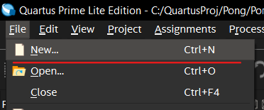
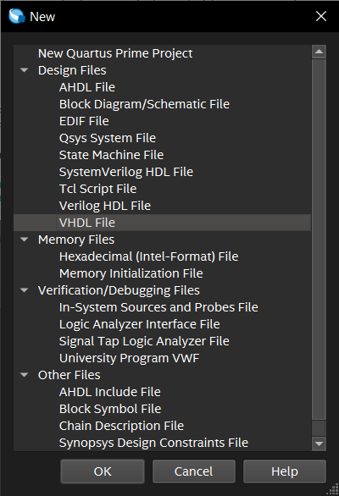
- In the new VHDL file, include the necessary IEEE libraries using the following code:
library IEEE;
use IEEE.STD_LOGIC_1164.ALL;
use IEEE.NUMERIC_STD.ALL;

- Write an architecture/entity pair in the new file with six input ports and one output port:
hcount | in | INTEGER | x-pos of current pixel
vcount | in | INTEGER | y-pos of current pixel
x1 | in | INTEGER | x-pos of left side of rectangle
x2 | in | INTEGER | x-pos of right side of rectangle
y1 | in | INTEGER | y-pos of top of rectangle
y2 | in | INTEGER | y-pos of bottom of rectangle
lit | out | STD_LOGIC | whether the current pixel is on the rectangle

- Write architecture logic to set lit to '1' when the current pixel is in the rectangle, '0' otherwise. It may be useful to know the syntax of conditional assignment, which allows conditional behavior without using a process:
var <= val_1 when (condition_1) else
val_2 when (condition_2) else
...
val_default;

This syntax will assign val_1 to var when condition_1 is met, val_2 when condition_2 is met, and so on; assigning val_default if none of the conditions are met. If more than one condition is met, then the topmost value will be prioritized. When this logic is synthesized (converted from HDL into logic elements for the FPGA), it will become a multiplexer element.
- Write a component definition and instantiate a copy of your rectangle component (like you did for the PLL in Part 1) in the renderer component. Use constant values and the lit output to draw a rectangle on screen, modifying your test pattern if necessary.
- Compile and upload your code. If you successfully display a rectangle, continue to the next part.

Part 6 – Game Logic
In this part, we will write logic to drive the movement of paddles in the game logic. We will also learn an idiomatic way to create a state machine in VHDL to control game elements.
For this part, we will be working mostly in the game_logic.vhd file. The game_logic entity has 7 inputs and 6 outputs. Read the comments next to each port to learn more about them. The file also contains a process which serves as the main game loop, and updates the game state every frame. Presently, the game loop deals with the motion of the ball, detecting collisions with the walls and paddles, and scoring logic.
You may notice that many of the output ports have variables within the process that are modified internally before being assigned out (e.g., ball_x is assigned to a variable named bx_n, which is the one used in the process). In VHDL, an out port cannot have its value read from within the component. To allow us to make decisions based on the present value, and keep the entity declaration clean, we create an internal variable and assign the outport to that. This is a common idiom in VHDL.
To draw the game to the screen, we will use some prewritten logic that depends on the rectangle component you wrote earlier:
- Instantiate the game_logic component in hdmi_top, and map the proper ports, creating appropriate signals for the ports not mentioned below, referencing the entity declaration:
- clk: our PLL 74MHz clock signal
- game_clk: our frame_start signal from the video_timing component
- reset: (not pll_locked) or reset (we don’t want to run game logic until the PLL is back after a reset)
- pl_up, pl_dn, pr_up, pr_dn: not key(0), not key(1), not key(2), not key(3), respectively
- Uncomment the lines in the port declaration of renderer (i.e., pl_y, pr_y, ball_x, ball_y, score_l, and score_r) and update the instantiation in hdmi_top to pass along the signals from game_logic.
- Uncomment the component instantiations in renderer (to draw the paddles and scores).
- Remove the logic to color your test square and add logic to draw the paddles and ball using on_pl, on_pr, and on_ball.
Now, we will write the logic to move the paddles:
- In the game_logic architecture, write logic to move the paddles up and down when their respective buttons are pressed. Include checks to prevent them from moving out of the screen bounds. Note, you can use the clamp function in the architecture to bound a number between two values, like so:
signal <= clamp(val, min, max);
Lastly, we will implement a state machine to add a brief delay between a goal being scored and a new round starting. Put simply, a state machine is a set of states (only one of which can be “active” at a time), a list of behaviors for each state, and a list of ways to move between states. For more information on state machines, see Appendix D. For our game, the state machine will consist of two states:
- The gameplay state: in this state, the game logic will run as normal
- The serving state: in this state, the ball will be frozen in the center of the screen, and a serving counter will be decremented each frame.
Whenever a goal is scored, we move to the serving state. Whenever the serving counter reaches zero, it is reset, and we move to the gameplay state. This state machine is illustrated in Figure 3.
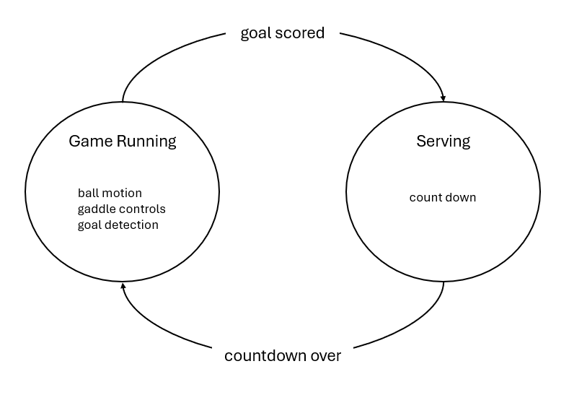
Figure 3 - Game state machine
To implement this state machine, we will create a new type to represent the state of the game, logic to change the game behavior depending on the state, and logic to change the state:
- To create a type for game state in VHDL, we can add the following definition above the begin keyword in our game_logic component:
type GAME_STATE is (
ST_GAMEPLAY,
ST_SERVE
);
For those familiar, this style of type definition is very similar to a C enum.
- Create a signal to track game state. Initialize it as ST_GAMEPLAY. To use our custom type, use GAME_STATE where you would typically put STD_LOGIC.
- In the game_logic architecture, beneath the begin statement, wrap the ball motion logic in the following case statement (which should be familiar to those with programming experience):
case state is
when ST_GAMEPLAY =>
-- ball movement logic
when ST_SERVE =>
-- serving logic
end case;

- Modify the goal logic to change the state to ST_SERVE when a goal is scored.
- Add logic to the ST_SERVE case to decrement the serve counter each time the process is clocked. Also add logic to reset the timer and change the state to ST_GAMEPLAY when the timer is complete.
- Add logic to set the state to ST_SERVE and to reset the serve duration when the reset button is pressed.
Now, you should have an operational version of pong running on your FPGA.
If you’ve finished the workshop early, or you’re interested in taking the project further, here are some ideas to pursue or inspire other projects (listed by approximate difficulty):
- Adjust the score tracking & rendering to accommodate double-digit scores
- Change the ball’s trajectory depending on the paddle’s speed/direction when it’s hit
- Change the rendering logic to make a faux-3d effect, add shadows, or create other effects
- Create a four-player version of the game
- Write a random number generator and use it to add power-ups (fun fact, because FPGAs use reprogrammable hardware, true random number generation is possible using ring oscillators)
- Add sound effects (the FPGA board can transmit audio over the built-in 3.5mm audio jacks)
- Reimplement the game using a Nios soft-core processor and integrate it with FPGA logic elements to create a hardware-accelerated software game
- – I2C Protocol
I2C (Inter-Integrated Circuit, I²C) is a serial communication protocol. Its main use is communication between integrated circuits over low speeds and short distances. It allows communication between multiple controllers and multiple targets using just two wires.
I2C communication is performed over two wires, SDA (the serial data line), and SCL (the serial clock line). Both lines are driven by open collector drivers to destructive bus conflicts. A typical wiring diagram for I2C is illustrated in Figure 4.
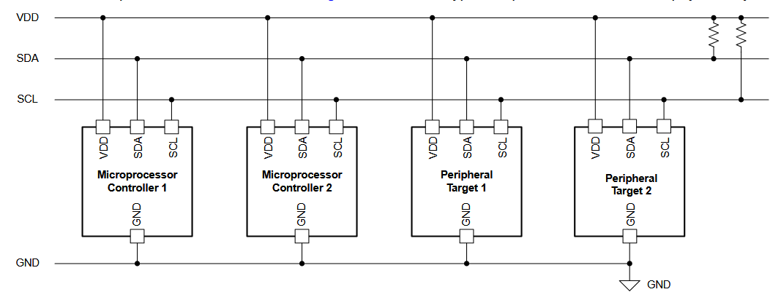
Figure 4 - Typical I2C Wiring
In I2C, the controller devices are responsible for driving the SCL line. To claim the bus and mark the beginning of a transmission, a controller will drive SDA low, then drive SCL low. To mark the end of a transmission, a controller will release SCL back to high, then release SDA back to high. This is how data is synchronized at the packet level. These start- and end-of-transmission signals are illustrated in Figure 5.
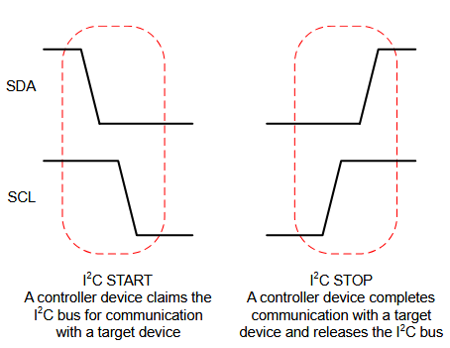
Figure 5 - I2C Packet-Level Synchronization
To transmit values, SDA is released to VDD (a logical ‘1’) or driven to ground (a logical ‘0’). These changes are clocked by SCL, so they are driven to the line while SCL is low and read when SCL is high. This is how data is synchronized at the bit level. See an illustration of this process in Figure 6. Note that the I2C start and stop signals both involve changing the value of SDA while SCL is high. This allows devices to differentiate the start and stop signals from logical ones and zeros, since nowhere else in a transmission does SDA change while SCL is high.
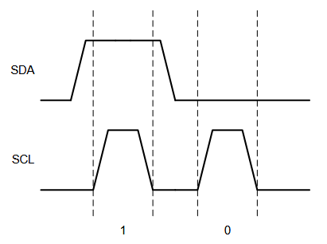
Figure 6 - I2C Bit-Level Synchronization
A complete I2C transmission consists of a start signal, an address frame, one or more data frames, and a stop signal. Address frames and data frames are identical in structure, but an address frame is interpreted by target devices to determine whether the transmission specifically targets them.
I2C frames are each made up of 9 bits, 8 for data/addresses and one for acknowledgement from the target device. The sender of the frame (the controller for address frames and writes, the target for reads) will transmit the 8 data bits in sequence. Then, the receiver drives SDA low at the clock cycle to acknowledge it received the frame. An entire I2C transmission is illustrated in Figure 7.
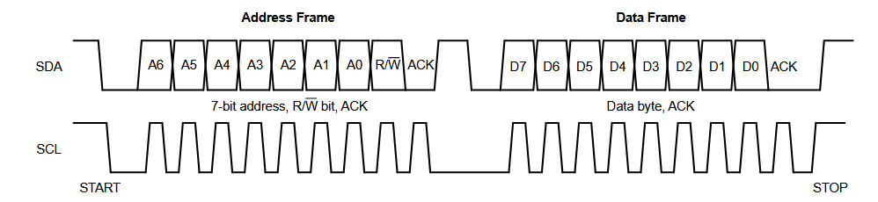
Figure 7 - I2C Transmission
The data bits of an address frame include a 7-bit I2C address, unique to each target on the network, and 1 bit to specify whether the transmission is a read or write (‘1’ for read, ‘0’ for write). The number of data frames and their contents is up to the target device’s specifications.
For a more in-depth explanation of the I2C protocol, see this document from Texas Instruments (also archived here).

FPGA Implementation
To properly power on and configure the ADV7513 encoder, we need to send three separate write commands. The ADV7513 specifies two data frames for write commands: the first is the internal address of the register to write, and the second is the data to write.
The I2C protocol is implemented by a simple state machine. Using a clock divider, the 74.25MHz clock is scaled to a 200kHz clock. Then, the state machine iterates with each pulse of the 200kHz clock. The general idea of the state machine is to iterate over the three commands to send over I2C. For each of those commands, it iterates over the frames to send, and the bits within those frames. A diagram of the state machine is illustrated in Figure 8.
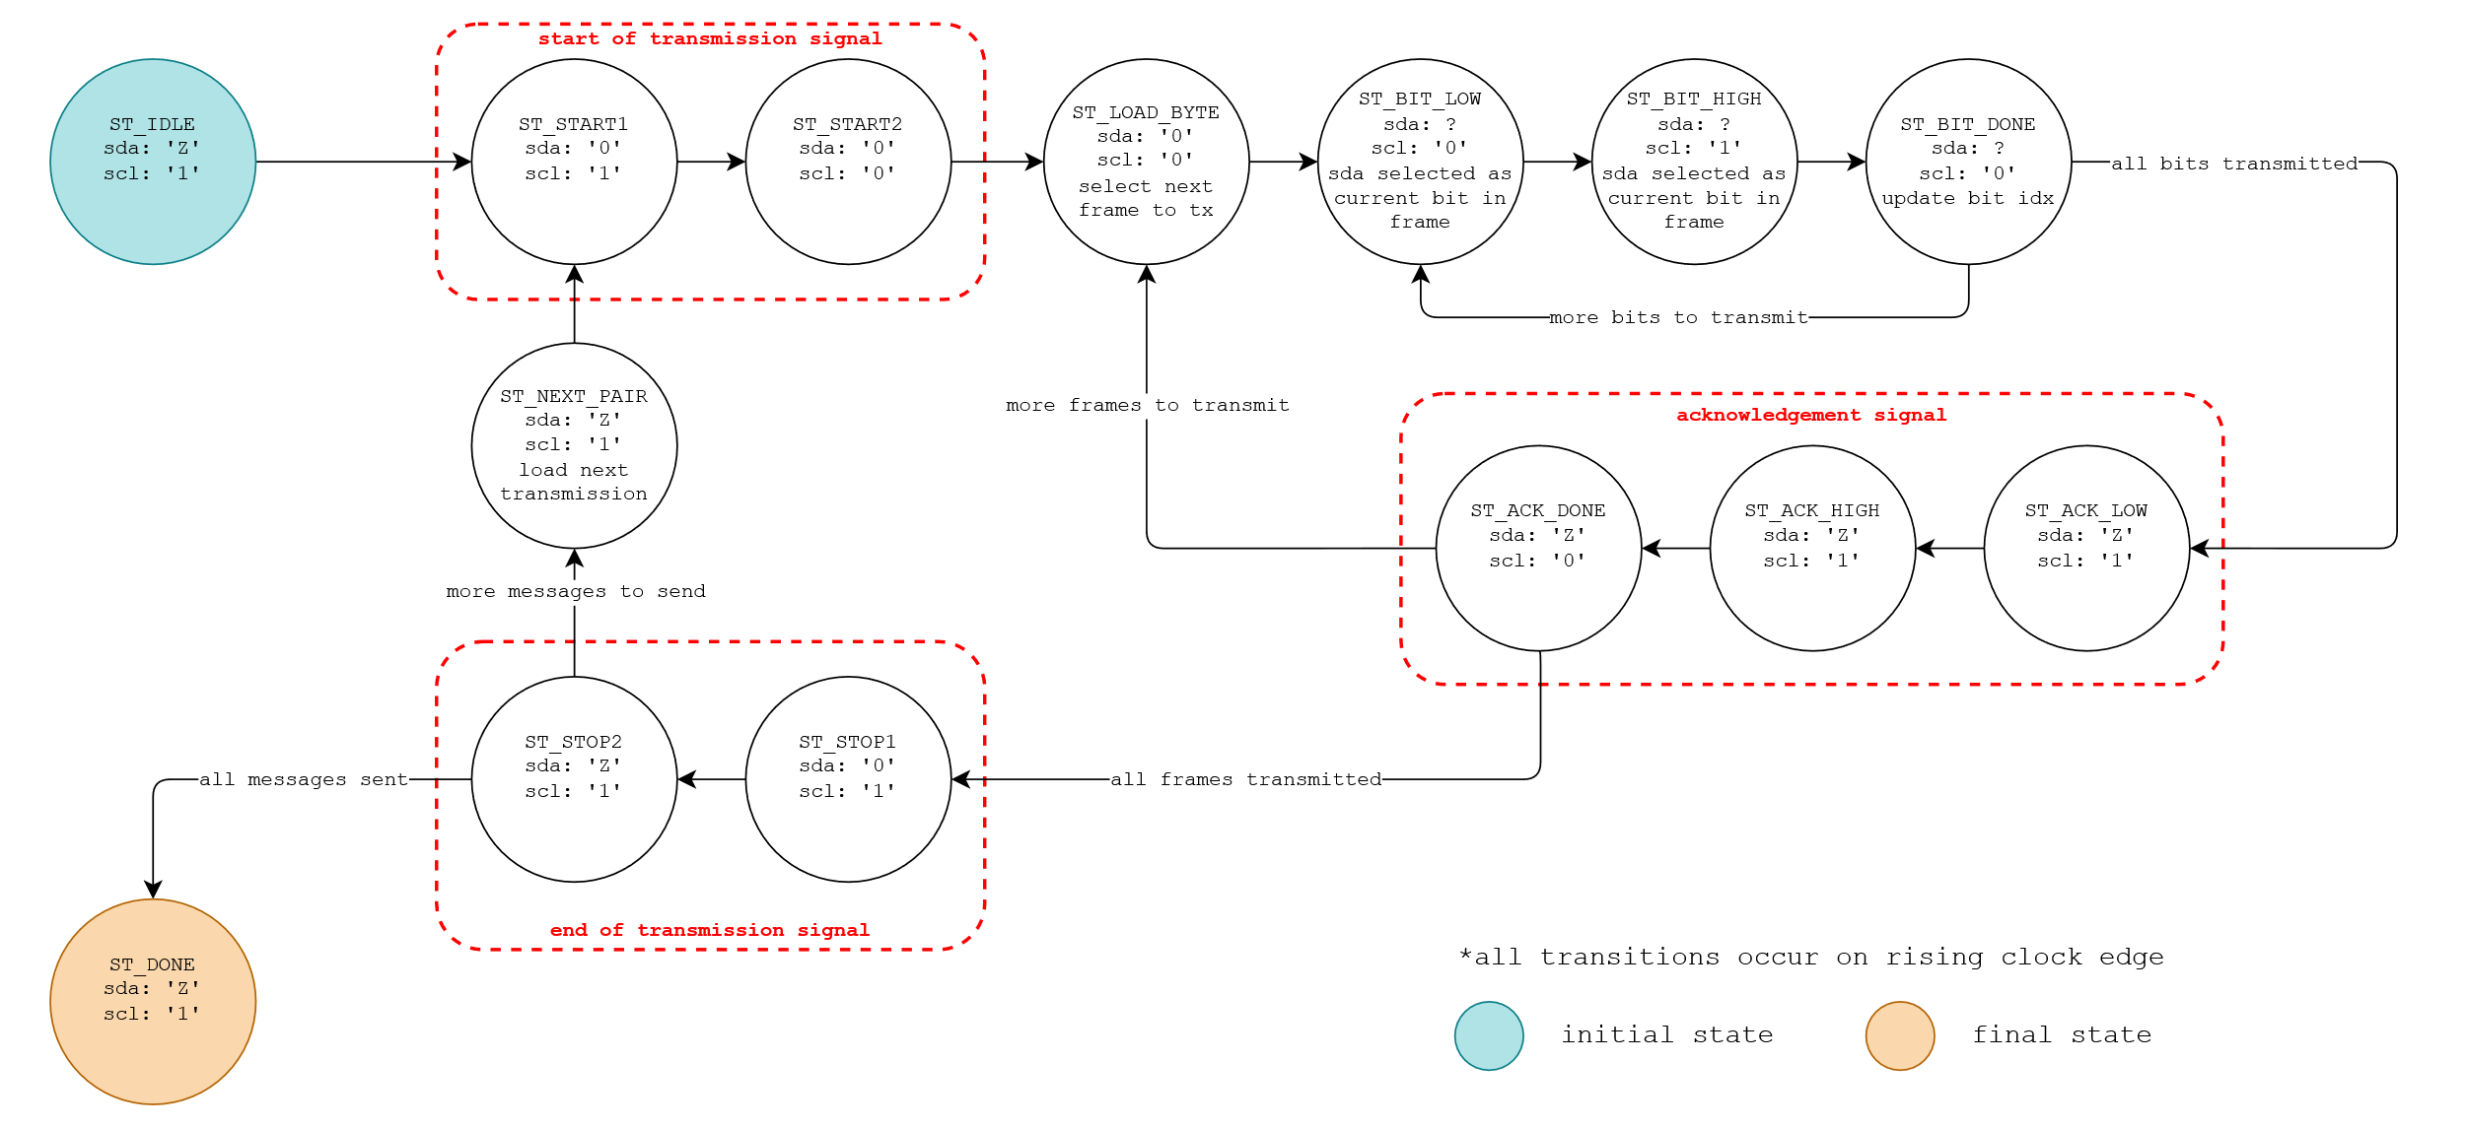
Figure 8 - I2C State Machine
Note, the I2C configurator does not check for an acknowledgement signal from the ADV7513. This was deemed acceptable, since, in testing, the ADV7513 never failed to acknowledge a frame. Additionally, failure to transmit a configuration frame is not critical as the program can be manually reset and the configuration retransmitted if the setup fails.
One additional implementation detail of the I2C configurator module is the use of an open-collector driver. Because FPGAs are programmable hardware gates, it’s possible to use more than just '1's and '0's for logic – in fact, that’s the purpose of the STD_LOGIC type! STD_LOGIC supports a variety of signal types beyond just '0' and '1' and attempts to extend boolean algebra for those values. In our component, we use the high-impedance value, 'Z', to dictate a non-driven open collector driver output. SCL uses a push/pull driver since the FPGA is the only I2C controller on the bus.

- – Video and the ADV7513 Encoder

Horizontal and Vertical Sync
In this workshop, we used horizonal sync (h-sync), vertical sync (v-sync), and data enable (DE) signals to control the video timing of our HDMI display. These signals are used by the display to recognize the ends of rows of pixels, and the ends of a complete frame of pixels.
H-sync and v-sync are part of a lineage of compatibility originating from CRT displays. In CRT displays, images are displayed by shooting a thin beam of electrons, known as the scanline, at phosphorescent materials on the face of the display. The scanline moves across the face of the display many times per second, from left to right, top to bottom, leaving a trail of dimly glowing material whose brightness corresponds to the intensity of the electron beam. By varying the intensity of the electron beam as we move it, we can draw an image onto the screen. We perceive the quickly moving beam as a cohesive image because of a phenomenon known as persistence of vision.
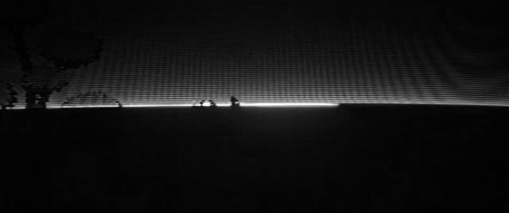
Figure 9 - Image of scanline moving across a CRT with 12μs exposure, courtesy of The Slow Mo Guys
To draw an image to the display, we need to provide a signal corresponding to the desired brightness of the image at the current position. To synchronize the position of the scanline on the display with the brightness data being sent, we send two additional signals to the display: an h-sync and a v-sync signal. The h-sync signal tells the display to move the scanline back to the left and down a line. The v-sync signal tells the display to move the scanline back to the top-left of the screen. The motion of the scanline with respect to the h-sync and v-sync signals is shown in Figure 10.
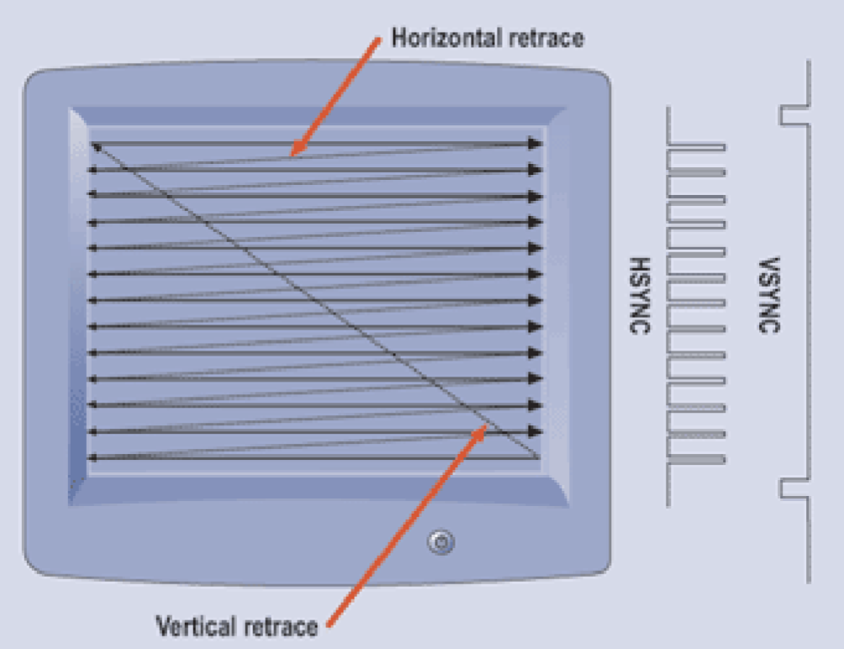
Figure 10 - Scanline Path
To prevent artifacts from the beam changing directions while lit, additional space before and after the visible areas are added, which gives the beam time to turn off before the move and on after the move. These spaces are known as the front porch (the area before the visible zone where the beam turns on) and the back porch (the area after the visible zone where the beam turns off). H- and v-syncs occur in the time between front and back porches. To avoid sending brightness data while the beam is in the non-visible areas, we use one more signal, data enable (DE). DE tells us when we’re outside the visual area, and it’s used to shutter the beam.
Modern displays use different methods to display pixels, but the ADV7513 still supports h-sync and v-sync signals to synchronize video data transmission.

Resolutions and Supported Timings
In the workshop, we used a pixel clock of 74.25MHz. This clock speed was chosen to match the desired framerate with the horizontal and vertical resolution we are displaying, the h-sync and v-sync durations, and the front and back porch durations. In this workshop, we have a visible display area of 1280x720 pixels. However, each row also includes 110 pixels worth of front porch, 220 pixels worth of back porch, and 40 pixels worth of h-sync (e.g., the front porch lasts the same duration it would take to scan 220 pixels, etc.). Additionally, each frame has 5 rows worth of front porch, 20 rows worth of back porch, and 5 rows worth of v-sync. All told, this gives us an equivalent horizontal resolution of $1280+110+220+40=1650$ pixels. Similarly, it gives us a vertical resolution of $720+5+20+5=750$ rows. So, for each frame, we need to send $1650⋅750=1237500$ pixel clock pulses. Since we display our game at 60 frames per second, our clock must run at a rate of $1237500\frac{\text{cycles}}{\text{frame}}⋅60\frac{\text{frames}}{\text{second}}=74250000 \text{Hz}=74.25 \text{MHz}$. You may try changing the resolution of the game, but many monitors only support certain standard resolutions, framerates, and timings. This tool will help you select timing parameters and let you know which protocols support your chosen resolution, framerate, and timing parameters.

Encoder Configuration
The ADV7513 HDMI encoder supports a variety of interesting features, including hot-plug detection, I2S audio, and 3D video. For the purposes of this workshop, the chip was configured to use 24-bit RGB (4 bits each for red, green, and blue channels) with separate video synchronization signals, no I2S audio, no High-bandwidth Digital Content Protection (HDCP, a protocol to prevent unauthorized copying of material by interception along the HDMI cable), and HDMI mode.
-- init table; data to send to hdmi transmitter on startup
constant REG_CT: NATURAL := 3;
type REG_ARR is array (REG_CT-1 downto 0) of
STD_LOGIC_VECTOR(7 downto 0);

signal reg_addr: REG_ARR := (
x"41", x"15", x"AF"
);
signal reg_data: REG_ARR := (
x"10", x"10", x"06"
);

The above code sets up the sequence of I2C writes to send to the ADV7513 encoder. In the first message, we write 0x10 (0b00010000) to address 0x41. This powers on the chip. A register description for this address is shown in Figure 11.
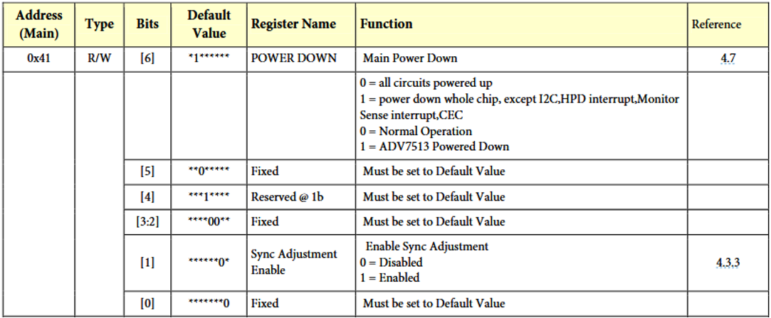
Figure 11 - Register Description of 0x41 for ADV7513
The second message writes 0x10 (0b00010000) to address 0x15. This sets the video mode to 24-bit RGB with separate synchronization and disables the I2S audio. A register description for this address is shown in Figure 12. Unfortunately, the development board we use in this workshop does not include the physical connections to the ADV7513 to use HDMI audio. It does however have a separate audio system that uses the three 3.5mm jacks on the side of the board.
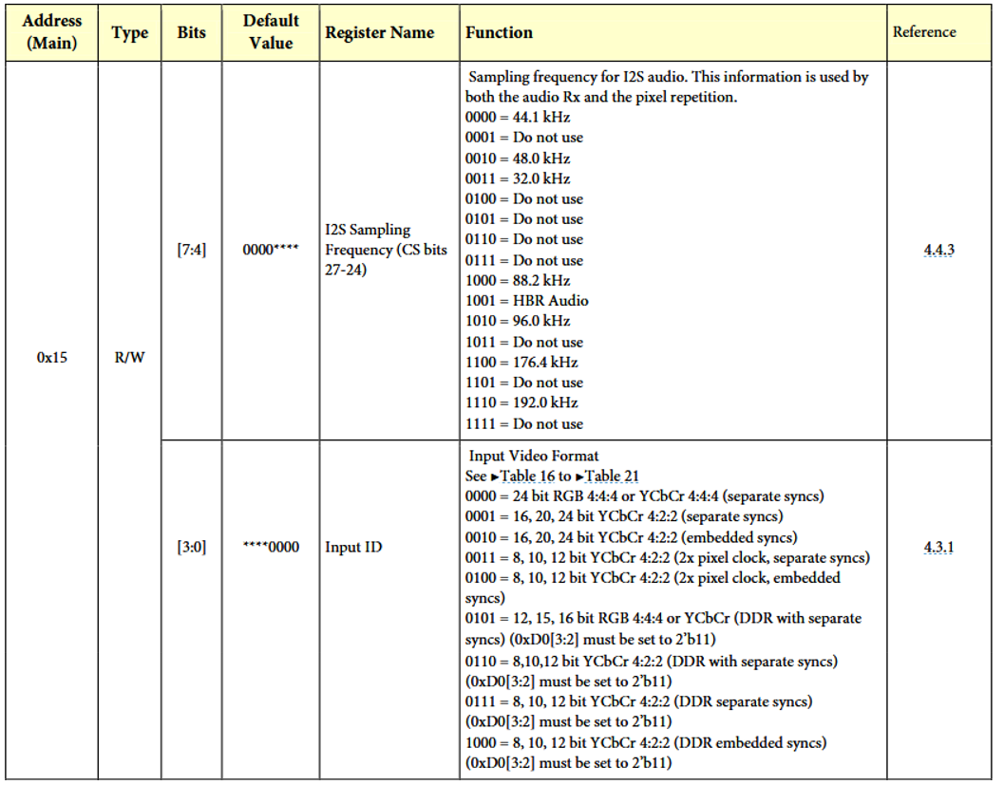
Figure 12 - Register description of 0x15 of ADV7513
The final message writes 0x06 (0b00000110) to address 0xAF. This disables HDCP, and configures the chip to use HDMI mode (rather than DVI mode, which pares down functionality for the sake of compatibility). A register description for this address is shown in Figure 13.
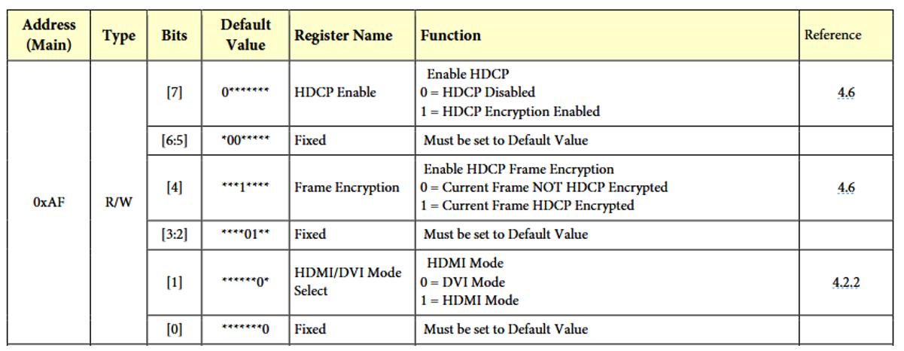
Figure 13 - Register description of 0xAF of ADV7513
More information on the ADV7513 can be found in its datasheet, its programming guide, and its hardware guide (archived here, here, and here, respectively). Notably, the programming guide includes a list of registers accessible over I2C and provides more information on configuring the encoder.

- – Phase-Locked Loops
Phase-Locked Loops (PLLs) are devices capable of generating new clock frequencies from a reference clock. The new frequencies are tightly coupled to the original clock, and maintain a constant phase relationship (i.e., one does not drift with respect to the other).
The simplest form of a PLL is one that generates a clock of the same frequency as the input clock. The most common implementation consists of a couple building blocks:
- Phase/frequency detector
- Charge pump
- Low-pass filter
- Voltage-controlled oscillator
The phase detector compares the output and input clock, determining whether the output clock is running slow or fast. The output of the phase detector is fed into a charge pump which tracks the frequency difference between the two clocks (think an integrator). The output of the charge pump is fed through a low-pass filter (to prevent random jitter from causing rapid overcorrections). Then, the filtered output is fed to a voltage-controlled oscillator, which generates the output clock. This circuit is illustrated in Figure 14.
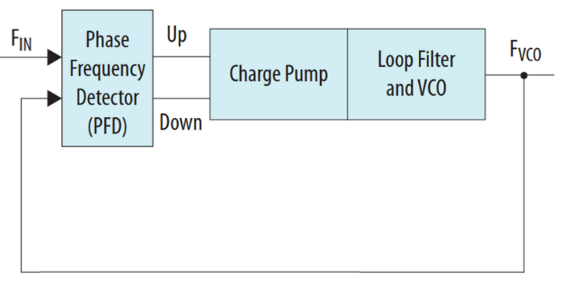
Figure 14 - Simple PLL
As the output clock drifts relative to the input clock, the phase detector sees the offset between the two clocks. It adjusts the charge pump in accordance, which influences the frequency of the VCO until the clocks are in-phase.
To generate clocks with frequencies other than the input frequency, we can use clock dividers to adjust the input and feedback frequencies. Consider the same circuit as above but with a clock divider before the phase detector, as shown in Figure 15.
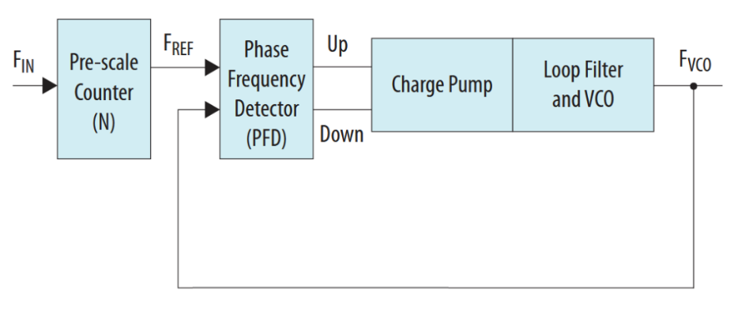
Figure 15 - PLL with input divider
In this configuration, ${F_{VCO}=F}_{REF}=\frac{F_{IN}}{N}$. From this, we can get new clock frequencies that are integer divisors of $F_{IN}$. This is still too limiting – what if we want an output frequency that is two thirds the input frequency, or that is double the input frequency? To make our PLL more flexible, we incorporate a second frequency divider in the feedback path of our PLL. This circuit is shown in Figure 16.
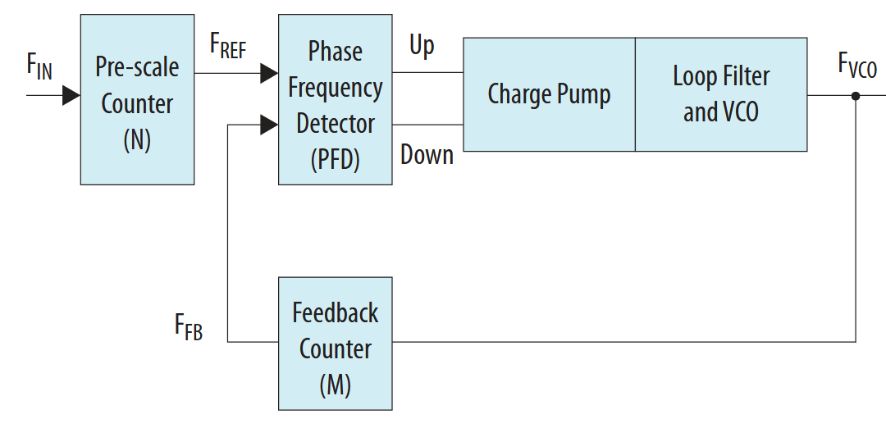
Figure 16 - PLL with input and feedback dividers
Here, $F_{FB}=F_{REF}=\frac{F_{IN}}{N}$, and $F_{FB}=\frac{F_{VCO}}{M}$. Thus, $F_{VCO}=\frac{M}{N}F_{IN}$. Now, we can generate any frequency that is a rational multiple of the input frequency. This arrangement is called a frequency synthesizer, as it can generate an arbitrary frequency from a reference frequency within any specified accuracy. It’s often used to generate a variety of clock frequencies with no drift relative to a single central clock (as we did in our workshop).
In a real-world design, we are limited by the range of our divisors, i.e., the maximum and minimum values of $M$ and $N$. This is why when we generated our PLL IP in this workshop, we could not generate an exactly 74.25MHz signal. The problem of approximating a real number with rational numbers is known as Diophantine approximation.
To learn more about PLLs and their implementation, see the documentation for the PLL component we used in today’s workshop here (also archived here). Additionally, the Wikipedia page for PLLs is a valuable resource.
- – State Machines
A finite state machine (FSM) is a machine that can only ever be in one of a finite number of states at any given time. The state of the machine can only be changed in response to some input, and this change is referred to as a transition. The different states and transitions are what are used to encapsulate a set of behaviors.
One example of a simple FSM is a traffic light. If the light has been green for long enough, it will transition to amber to indicate a stop will start soon. However, the green light must never transition from green immediately to red, since this would be a safety issue. Thus, the FSM for the traffic light does not include a transition from green directly to red. An illustration of a simple traffic light FSM is shown in Figure 17.
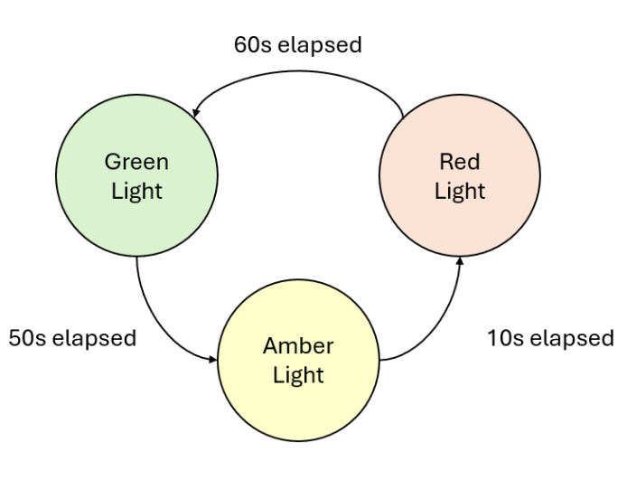
Figure 17 - State machine for traffic light

Fun Fact: State machines are extensively used in game development. For example, if you’re playing Super Mario and you hit the A button on the controller, Mario’s state transitions from standing to jumping. You may have also noticed that in a few games you can’t do a combination of actions like jumping and swinging a sword simultaneously. This might be because these actions are independent states, and there is no such transition between them, and thus there is no way for the character to jump and swing their sword. For more info on how state machines are used in game development, see this video.

A finite state machine can be completely defined by:
- The set of all states in the state machine
- The set of all transitions between the states (i.e., which states a given state can transition to, and why)
- The initial state of the machine
Pair Detector Example
A pair detector is a device used to identify pairs of 1s from a stream of incoming bits (i.e., we only have access to the next incoming bit in an ongoing sequence of bits). For example, in the stream of bits 110101000110 (arriving in order from left to right), there should only be two pairs identified: 110101000110.
To implement an FSM capable of detecting pairs, we’ll first consider what possible states the machine should have. Since we’re only detecting pairs of bits, our state machine only needs to encode the two latest bits we received as states. So, we’ll create four states: 00, 01, 10, and 11. Then, we’ll create transitions between the states based on what the most recently received bit is (e.g., if we’re in state 01 and receive a 1, we’ll transition to state 10). Then, we need to determine behavior for each of our states. A pair will only have been received if we’re in state 11 (i.e., 2 consecutive 1’s), so we’ll make state 11 output 1 to indicate a pair, and the other three states output 0 to indicate no pair. We’ll choose our initial state to be 00.
Drawing this state machine, we get the following:
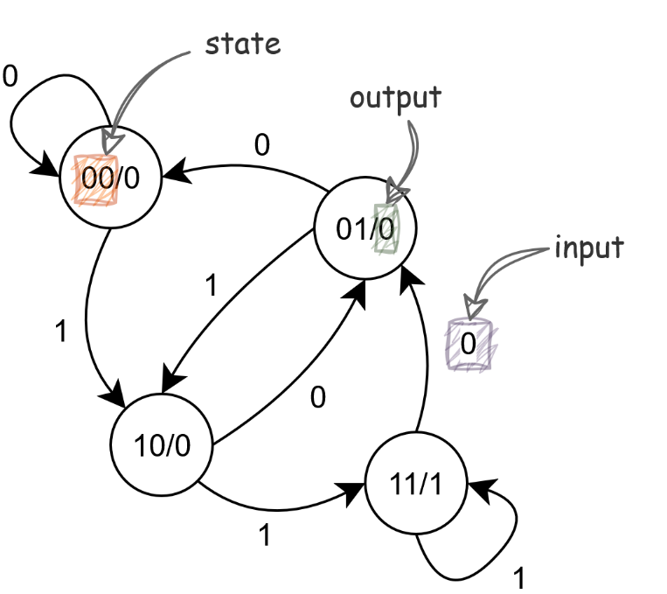
Figure 18 - State diagram for pair detector
The diagram shown in Figure 10 can be interpreted by starting in state 00. For each bit received, follow the arrow with the received value to the next state. For example, in the number 110101001010, we’d start in state 00. When we receive the next 1, we transition to state 10. Then, the next 1 is received, changing the state to 11 (which outputs 1, a pair is detected!). This process continues as long as bits are received.
A pair detector could be implemented in VHDL as follows:
signal state: BOOLEAN_VECTOR(1 downto 0);

process(clk) is
begin
case state is
when "00" =>
pair <= '0'
when "01" =>
pair <= '0'
when "10" =>
pair <= '0'
when "11" =>
pair <= '1'
end case;

-- instead of writing each transition out,
-- we'll write them as a rule since they
-- all follow a consistent pattern
state(0) <= state(1);
state(1) <= in_bit;

end process;

state is the signal that stores our current state. Since our state has a clear bit-wise representation, we’ll use a BOOLEAN_VECTOR of size 2. Notice we’re not using a STD_LOGIC_VECTOR, since this would include states like "ZZ".
The case statement determines the behavior of the FSM based on the current state. In this example, the behaviors for each state are very simple, outputting '0' for no pair, or '1' for a pair. In a more complex state machine where transitions do not follow a general rule, we would also put state transitions in the case statement.
However, because all our transitions use a general rule of thumb, we embed them with two simple assignment operators, pushing our latest received value onto the state.
Similar to the RTL logic viewer in Quartus, there is also a tool to see state machines in your project. To open this tool, select Tools >> Netlist Viewers >> State Machine Viewer.
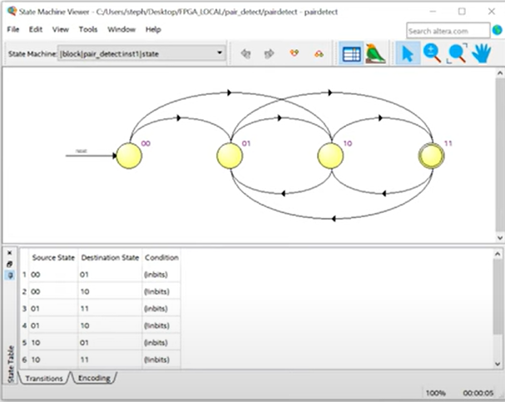

Mealy and Moore State Machines
Two different approaches can be taken to generate outputs from a state machine. These two approaches are classified as Mealy state machines and Moore state machines.
In a Mealy state machine, the output is a function of the present inputs and the present state as shown in Figure 19.
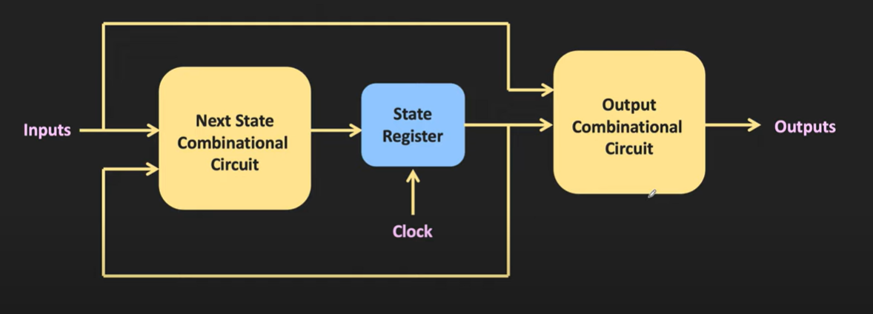
Figure 19 - Mealy Machine overview
In a Moore state machine, the outputs only depend on the current state, as show in Figure 20. Note, this does not mean the inputs have no impact on the outputs, just that the inputs can only modify the outputs by changing the state.
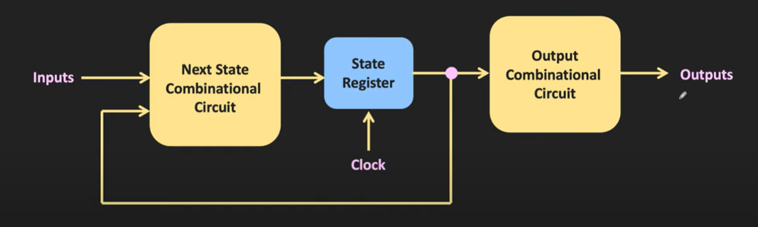
Figure 20 - Moore Machine Overview
To learn more about the differences between these two machines, see this video.

